**PCB TRAVEL POSSIBILITES**

Hello everyone,

Many of you have commented how enjoyable it was to travel down to the TBA State convention and how some of our best performances are those in which we prepare for major events outside of the Plano area.

You might recall that a few of months ago, we mentioned the possibility of considering another band trip in our future. We talked about one particular option in Seattle at the Western International Band Clinic in 2016. As a follow up, we wanted to share a little more info about that event as well as a few other potential options.

Please take a look at the list of events below. We would love to get your thoughts on these options and welcome other ideas as well. Of course, if we all decide to take another trip, it would likely include some personal expenses similar to our trips in the past (Pensacola, San Antonio etc.). As we have done in the past, we would explore options for fund raising to offset as much cost as possible.

Your feedback is important so please take a few minutes to look at these brief trip ideas and feel free to reply with any initial thoughts. And, of course, we have no plans to make ***any*** commitments without clear consensus.

Thanks in advance for your input and we look forward to receiving your thoughts.

The Plano Community Band Board

**Annual Western International Band Clinic – Seattle Wash. (3rd week of Nov. 2016)**

This is a highly touted clinic which attracts the best high-school bands and directors in the region. Other Texas bands have performed here including Texas A&M and others. The clinic is several days so this would be a 3-5 day trip.

Performance venue: Hotel Ballroom

Audience: Large audience of High School Band kids and Directors

[*https://www.****bandworld****.org/WIBC/*](https://www.bandworld.org/WIBC/)

[*www.****seattle****.gov/****visit****ing-****seattle****/points-of-interest*](http://www.seattle.gov/visiting-seattle/points-of-interest)

Venue:

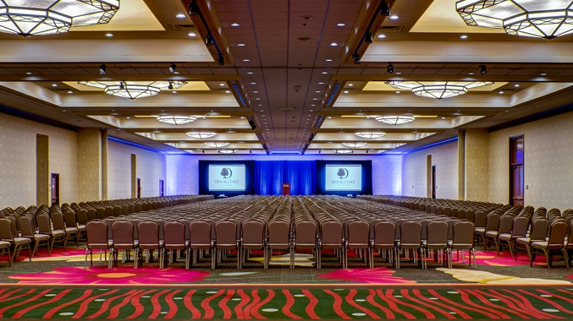

**Annual Texas Bandmasters Association - San Antonio, TX (same event as we did this year in San Antonio playing for the leadership day)**

Third week of July annually. San Antonio This invitation will probably be 2 or 3 years in the future. It would be a two-day event with roughly five community bands performing.

Performance venue: Lila Cockrill Auditorium

Audience: High school musicians and directors. About 1600 attended our concert in July of 14

www.texasbandmasters.org

www.**visitsanantonio**.com/

Venue:

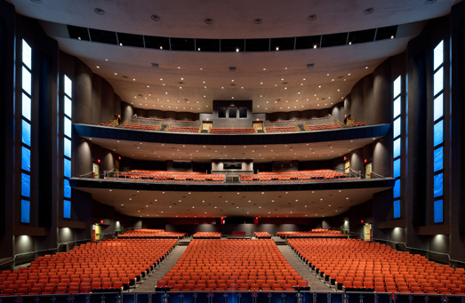

**Annual Mid-West Band and Orchestra Convention - Chicago Illinois**

**(3rd week of December 2017)**

By invitation only, (with pretty stringent requirements – but still very much possible for us) this is a very exclusive event that would require a 3-4 day trip .Mid-West was started by music publishers to showcase their new music each year. Invited groups play a program of the new literature from very easy to advanced.

Performance venue: Hotel Ballroom performance venue or McCormick Place West

<http://www.midwestclinic.org/default.aspx>

[www.choose**chicago**.com](http://www.choosechicago.com)

Venue:

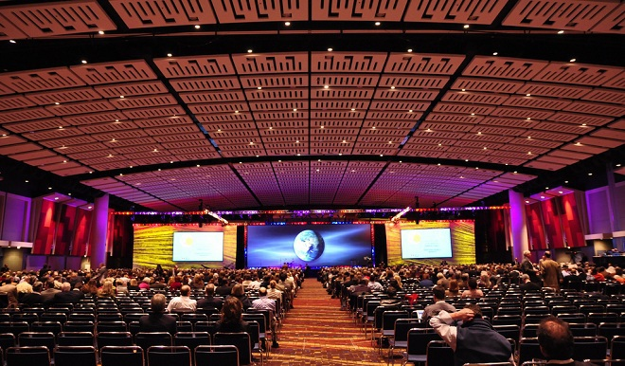

**Future ACB convention** – Ft. Lauderdale 2017 (mid- spring)

We are very familiar with the ACB conventions having hosted one ourselves recently. Participation would require a 3-4 day trip.

Venue: TBD (likely hotel ballroom)

Audience: Similar to ACB conventions in the past consisting of music professional and students. Attendance size between 300-600.

www.acbands.org

Downtown Ft. Lauderdale:

